RISE Campaign Builder

Replicating Engage Task Lists in RISE
Agent Guide
If you used Engage to manage your follow-up tasks, you already understand the value of having a structured reminder system tied to where a contact is in your sales flow. This guide shows you how that same system works in RISE — and how to take advantage of it.

BACKGROUND

From Engage Task Plans to RISE Campaigns
In Engage, task plans were pre-built lists of follow-up actions tied to stages in the sales flow — leads, marketing, buyer, and seller. When a contact moved into a stage, you received a structured checklist of calls, emails, and reminders at specific intervals.

RISE replicates this behavior through Campaigns. A Campaign in RISE is an automation — a sequence of tasks, delays, and conditions that triggers automatically when a contact meets specific criteria, like moving into a new stage.

Think of it this way: Engage task plan = RISE Campaign set to trigger on Stage Change, with Create Task actions built into the flow.

Key Terminology: Engage vs. RISE
In Engage | In RISE
Sales Flow | Workflow Stages (Board View)
Task Plan | Campaign (task automation)
Lead / Marketing / Buyer / Seller Plan | Stage: Lead, Nurture, Warm, Hot, etc.
Groups | Tags
Contact Label | Contact Type (Buyer / Seller / Unclassified)

The Contacts Board: Your Stage Overview
In RISE, go to Contacts and select the Board view. This shows every contact organized by their current stage in your pipeline — Lead, Nurture, Warm, Hot, Under Contract, and Post Close. Each contact card also shows their Contact Type (Buyer, Seller, or Buyer/Seller).

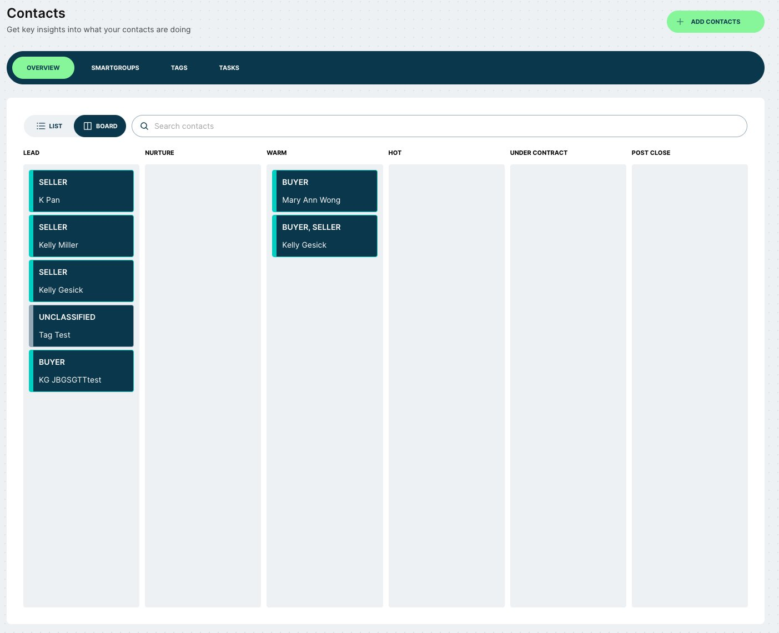

This is the equivalent of the Engage sales flow view. As you move contacts between stages, RISE Campaigns can automatically trigger the right tasks for each stage.

HOW IT WORKS

Understanding Task Automation in RISE
RISE automates tasks through Campaigns. Every task automation Campaign follows the same basic structure:

Trigger | Condition (optional) | Action | Delay + Repeat
Stage Change fires when a contact moves into a specific stage | Optionally filter by Contact Type (Buyer or Seller) for targeted tasks | Create Task: add a call, email, reminder, meeting, or text | Add delays between task groups; repeat conditions to control flow

Step 1 — Set Up Your Recipients and Trigger
When creating a Campaign, set Recipients to All Contacts. This ensures RISE will evaluate every contact in your database against the trigger conditions.

Set the Trigger to Stage Change, then choose the stage you want to target (e.g., Lead).

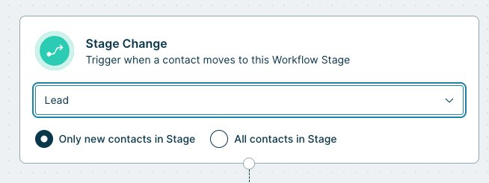

Important: New Contacts Only vs. All Contacts in Stage

Only new contacts in Stage — Use this if you already have contacts in that stage and don't want to re-trigger tasks for them.
All contacts in Stage — Use this if you want the automation to apply to everyone already in the stage, plus all future contacts.

Step 2 — Optionally Add a Contact Type Condition
If you want different task lists for Buyers vs. Sellers (for example, in the Hot or Warm stage), add a Contact Profile Detail condition and set Contact Type to Buyer or Seller. This tells RISE to only trigger the automation for contacts that match that classification.

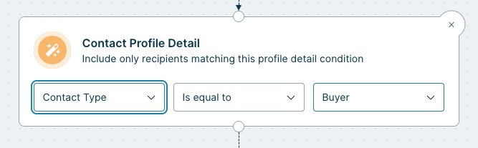

Note: For Lead-stage automations, you often won't need a Contact Type condition yet — you may not know whether a new lead is a buyer or seller until early outreach is complete.

Step 3 — Add Create Task Actions
Add one or more Create Task actions to the Campaign flow. For each task, specify:
- Task name (e.g., 'Call lead — introduce yourself')
- Task type: Call, Email, Meeting, Reminder, Text, or Custom
- You can stack multiple tasks to trigger at the same time

To replicate the Engage cadence of tasks on Day 1, Day 3, Day 7, etc., add a Delay block between groups of tasks, then add a Condition block to confirm the contact is still in the same stage before the next tasks fire.

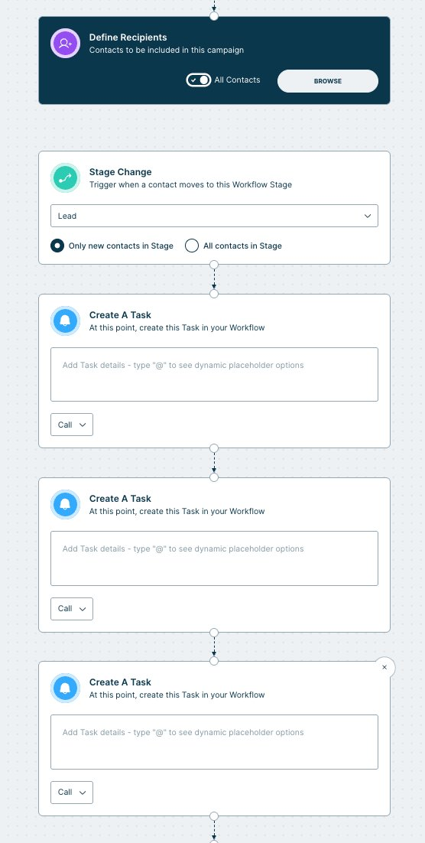

Why add a Condition after each Delay?

If you move a contact from Lead to Hot during the delay period, you probably don't want them to receive the remaining Lead tasks. Adding a Condition that checks the contact's current stage (e.g., still in Lead) acts as a gate — if they've moved on, the automation stops for them. This prevents irrelevant tasks from cluttering your workflow.

Step 4 — Save and Start
When your Campaign is built, click Save. The Campaign will not go live until you click Start. Once started, RISE will begin evaluating contacts and creating tasks automatically based on the conditions you set.

RECOMMENDED CONFIGURATIONS

Task List Setups by Stage
Below are the recommended Campaign configurations that replicate each Engage task plan type in RISE.

Lead Task List (replaces Engage Lead Marketing Plan)
Configuration
Recipients: All Contacts | Trigger: Stage Change → Lead | Condition: None required

When to use this
Use for any new or incoming contact at the earliest stage of the pipeline. At this point, Contact Type (Buyer/Seller) is often unknown, so no classification condition is needed.

Example tasks to include:
- Day 1: Call lead to introduce yourself
- Day 1: Connect on social media
- Day 3: Send follow-up email, update contact status
- Day 7: Add to mailing list, set up neighborhood news
- Day 14: Schedule intro meeting or check-in call

Buyer Task List (replaces Engage Buyer Plan)
Configuration
Recipients: All Contacts | Trigger: Stage Change → Warm or Hot | Condition: Contact Type = Buyer

When to use this
Use when a contact has been classified as a Buyer and is progressing toward a transaction. The Contact Type condition ensures only Buyers receive these tasks.

Example tasks to include:
- Create and share Buyer Presentation
- Schedule property showings
- Conduct buyer needs review
- Create transaction in Skyslope / DocuSign

Seller Task List (replaces Engage Seller Plan)
Configuration
Recipients: All Contacts | Trigger: Stage Change → Warm or Hot | Condition: Contact Type = Seller

When to use this
Use when a contact has been classified as a Seller and is moving toward listing. The Contact Type condition ensures only Sellers receive these tasks.

Example tasks to include:
- Create and present CMA (Comparative Market Analysis)
- Share CMA and review with seller
- Review listing agreement details
- Create pre-listing home prep to-do list
- Mail thank you note
- Create transaction once listing is live

AT A GLANCE

Decision Guide
Use the questions below to determine which Campaign configuration is right for each situation.

If... | Then...
You are setting up tasks for a brand new lead and don't yet know if they are a buyer or seller | Use Stage Change: Lead with no Contact Type condition
You know a contact is a buyer and they are moving to Warm or Hot | Use Stage Change: Warm/Hot + Condition: Contact Type = Buyer
You know a contact is a seller and they are moving to Warm or Hot | Use Stage Change: Warm/Hot + Condition: Contact Type = Seller
You already have contacts in a stage and want this automation to apply to them | Select All contacts in Stage when setting up the trigger
You have already handled tasks manually for existing contacts in a stage | Select Only new contacts in Stage to avoid duplicate tasks
A contact moves to a new stage during a delay period | Add a Stage Condition after each Delay block — contacts that move on will exit the automation

Reminder: A Campaign does not go live until you click Start. Build and review your full task flow before activating. Once started, tasks will begin generating automatically as contacts meet the trigger conditions.

